www.artnc.org

Reading Art: Telling Stories about Ourselves
Writer: Carolyn Walker, English Language Arts Teacher
Grade Level: K–2
Related Big Picture Concepts: Identity, Meaning
Subject Areas: Art, Dance, Language Arts
Duration: 3–5 45-minute sessions
Essential Question: How do visual images convey meaning?

Abstract: Students explore visual images on an African ceremonial costume. Students will create costumes and dances to tell personal stories.

Focus Works of Art:
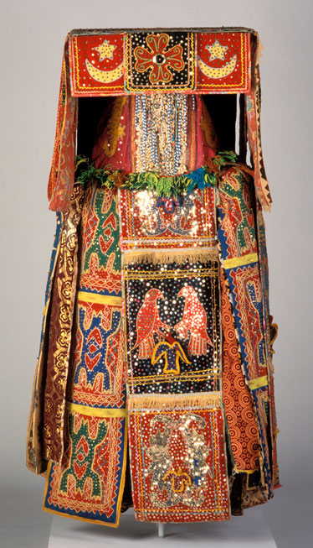
Popular Republic of Benin, Yoruba Peoples
Egungun Masquerade Costume, 20th Century
Cloth, wood, beads, coins, cowrie shells, and sequins
H. approx. 60 in. (152.4 cm)

North Carolina Standards Correlations
Visual Arts:
K.V.1.2, K.V.1.3, K.V.1.4, K.V.2.3, K.CX.1.1, K.CX.1.2
1.V.1.2, 1.V.1.3, 1.V.1.4, 1.V.3.3, 1.CX.1.1, 1.CX.1.4
2.V.1.3, 2.V.1.4, 2.V.2.3, 2.V.3.3, 2.CX.1.1, 2.CR.1.2

Dance:
K.CP.1.1, K.CP.1.2, K.CP.1.4, K.R.1.2, K.C.1.1, K.C.1.2
1.CP.1.1, 1.CP.1.2, 1.CP.1.4, 1.R.1.2, 1.C.1.1, 1.C.1.2
2.CP.1.1, 2.CP.1.4, 2.R.1.2, 2.C.1.1, 2.C.1.2

English Language Arts:
K.RL.2, K.RL.7, K.SL.2, K.SL.4, K.SL.5
1.RL.2, 1.RL.7, 1.SL.2, 1.SL.4, 1.SL.5
2.RL.2, 2.SL.2, 2.SL.4, 2.SL.5

Student Learning Objectives
- By exploring an African costume, students will develop understanding of how visual images convey meaning.
- By creating individual costumes and dances, students will apply this understanding to tell personal stories.

Activities
1. Show students an image of the Egungun costume. Ask them to identify the following:
- the types of figures or decorations on the costume (animals, birds, moons, stars)
- the colors they see
- the shapes they see
- the materials that make up the costume (sequins, fabrics, yarn, shells, gold thread)

Explain to the students that the decoration on this costume tells a story about the things that were important to the people who wore the costume. The costume was handed down from family member to family member, and people kept adding decorations to it over time. Ask: What do you think was important to people from this culture? What do you notice? Why do you think this is important? How do you think it changed over time?

2. Have students share experiences they have had wearing costumes. Ask:
How does it feel to dress up or disguise yourself? How does it feel to dance?

Explain to the students that the costume was usually worn while dancing. Ask them to predict what it would look like with a moving person inside it. Have them predict:
What do you think this dance would look like? How would the dancer make the costume come alive? What do you think the music sounds like? (Have them demonstrate the dance, if they wish.)

Once students have made their predictions, show them the video of an Egungun costume being worn and danced. (Video is located at http://carlos.emory.edu/ODYSSEY/AFRICA/AF_rit_cerem_mask_egungun.html.) Discuss what the dance movements might represent.

3. Tell the students that they are going to make a costume that tells a story about themselves. The costume will have many panels, and each panel will represent a different characteristic about the wearer or show something that is important to the wearer. (Developing a model of a few panels about yourself will help.) Have students think about some of the things they would like to communicate about themselves. Have them choose their most important qualities or values. (The teacher can make a list for each student. with pictures and labels, or older children can brainstorm a list together as a class.) Then have the students select a visual image that will easily communicate that quality or value to others. For example, students who like stories may choose a book for one of their panels.

Younger students may fill their panels with the following:
favorite animal
favorite color
favorite shape
favorite number
favorite letter

4. Give students several sheets of 8 1/2 x 11" colored construction paper. Tell them that each sheet should represent one of their qualities or values. Students can use an assortment of materials to decorate their construction paper panels, including fabrics from home, sequins, glitter, markers, paints, crayons, yarn, and shells. When they have completed their panels, give each student one piece of poster board or foam core cut in half, one for the front of the costume and one for the back. Have students glue their construction paper panels to the poster board or foam core. Tie the pieces of poster board or foam core together with yarn like a sandwich board for each student, allowing enough space for the child to pass his or her head through the opening.

5. Ask for some volunteers to create a dance that relates to the imagery on their costumes. Have the volunteers put on their costumes and dance for the rest of the class. Ask the music teacher to find some appropriate music for this activity. While each student is dancing, ask the other students to describe what is important to the performers based on the decorative elements of their costumes. After the student finishes performing, have him or her respond to the comments, either validating or correcting the group's assessment.

As an extension, have the entire class present their costumes to the rest of the school in a parade format or a dance performance.

Assessments
- Question students to determine understanding of shapes, colors, and animals, as well as how costumes can reflect customs and traditions.
- Assess the costume project, class discussion, and student participation to determine whether students have successfully communicated meaning through symbols.
- Assess the peer discussion to assess each student’s ability to communicate personal qualities and preferences through symbolic dance.

Resources

Vocabulary:

sequin

symbol

pattern

Materials:
Construction paper, foam core or poster board, fabrics from home, sequins, glitter, markers, paints, crayons, yarn, shells

Lesson Resources:
Egungun Masquerade Video
http://carlos.emory.edu/ODYSSEY/AFRICA/AF_rit_cerem_mask_egungun.html

